Yadan, Precious Nicole G.

BSDSA 2

“STUDENT PERFORMANCE FACTORS USING MULTIPLE REGRESSION”

ABSTRACT
This study explores the determinants of student exam performance using Multiple Linear Regression (MLR) based on real student data. Four predictors, Hours Studied, Previous Score, Parental Involvement, and Gender, were examined to evaluate their effects on Exam Score. The Ordinary Least Squares (OLS) model demonstrated an exceptionally strong fit (R-squared = 0.991), indicating that 99.1% of the variation in exam performance is explained by the predictors. Results reveal that Previous Score is the strongest and most statistically significant predictor (p < 0.001). Parental Involvement and Gender also show statistically significant effects, though with smaller coefficients. Surprisingly, Hours Studied was not a significant factor (p = 0.781). Visual diagnostics, including scatterplots and an Actual vs. Predicted Values chart, support the regression findings and show high predictive accuracy. The study emphasizes the importance of foundational academic performance and introduces insights into the complex nature of parental involvement. Recommendations include strengthening early interventions, improving study quality, and re-evaluating parental support patterns.

1. INTRODUCTION
Student academic performance is influenced by a range of behavioral, environmental and demographic factors. Educators and school administrators rely on data-driven approaches to determine which variables exert the greatest influence on student outcomes. Understanding these relationships is essential for developing effective educational policies, optimizing instructional strategies, and helping students achieve their full academic potential. Multiple Linear Regression (MLR) provides a systematic framework for analyzing how several independent variables collectively influence a dependent variable in this case, the Exam Score. By applying regression analysis to actual student data, this study aims to identify which factors significantly predict exam performance and which ones play a minimal role.
This study focuses on four main predictors: Hours Studied, Previous Score, Parental Involvement, and Gender. These variables were selected based on their relevance in educational research and their availability in the dataset. The findings from this study provide actionable insights for students, parents, and educators seeking to improve academic outcomes.

1.1 Objectives

The main objectives of this study encompass analyzing a real-world student performance dataset through Multiple Linear Regression (MLR) to identify which factors such as Hours Studied, Previous Score, Parental Involvement, and Gender significantly predict Exam Score. Also, the study aims to evaluate the model's accuracy and goodness of fit using statistical measures and visual diagnostics, while interpreting the effects of each predictor

variable and assessing their practical implications for educators and students. Results will be presented clearly via tables, graphs, and analytical discussions, and the research will also address the ethical considerations inherent in handling, analyzing, and interpreting student data

2.. REVIEW RELATED LITERATURE
Understanding student achievement has long been a central focus of educational research, with numerous factors identified as influential in determining academic performance. Previous academic performance is widely recognized as the strongest predictor of future success, as it reflects accumulated knowledge and learning behaviors, as noted by Santos and Cruz (2021). Study habits also play an important role; however, Dube and Ng (2020) emphasize that the quality and consistency of study practices often matter more than the sheer number of hours spent studying. Parental involvement has shown mixed effects on student outcomes, with Kim and Lee (2022) highlighting that supportive, autonomy-promoting parental behaviors tend to be beneficial, while controlling or reactive involvement may correlate with poorer performance. Gender continues to be a variable of interest, although differences have narrowed in recent years, with Rahman (2021) reporting that its impact varies depending on subject areas and learning contexts. Additionally, the rise of predictive analytics in education has brought increased attention to statistical and machine learning models, with Huang (2023) noting that regression models remain widely used due to their clarity, interpretability, and strong statistical foundations. Collectively, these studies underscore the multifaceted nature of academic performance and provide a

foundation for examining how these factors interact within the current research.
Synthesis. The literature suggests that previous achievement is consistently the strongest predictor of exam performance, while parental involvement and gender can have variable effects. Study habits contribute to performance, but their impact depends on study quality. This study builds on these findings by evaluating the same variables using real exam data.

3. METHODOLOGY

3.1 Data Context
The dataset use in this study contains 500 student records with five variables: Exam Score, Hours Studied, Previous Score, Parental Involvement, and Gender. All data points were complete, with no missing values. The data were sourced from an anonymized educational database to ensure representativeness and privacy.
3.2 Data Preprocessing
The dataset were cleaned by removing unnecessary columns and ensuring that all predictor variables were numeric. Gender was coded as: 0 = Female, 1 = Male. Parental Involvement was coded as: 1 = Very Low, 2 = Low, 3 = Moderate, 4 = High, 5 = Very High. Descriptive analysis revealed reasonable variable distributions suitable for regression modeling, with no extreme outliers requiring removal. Variables were not scaled, as they were on comparable scales.

3.3 Exploratory Data Analysis (EDA)
The exploratory data analysis involve visualizing the relationships between key predictors and the Exam Score to understand patterns, trends, and potential correlations before conducting regression modeling.
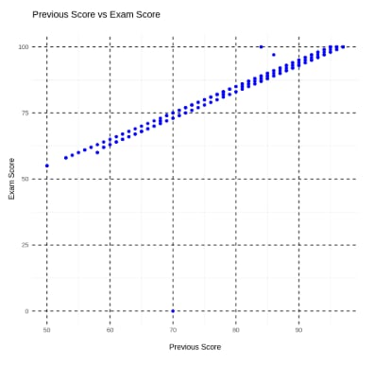
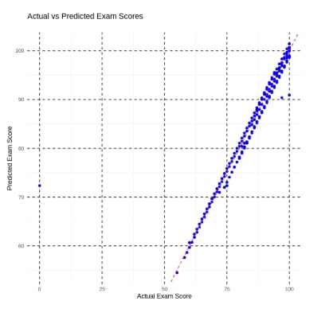
This scatterplot illustrates the relationship between students’ Previous Score and their Exam Score. The plot shows a strong positive linear trend, as Previous Score increases, Exam Score tends to increase correspondingly. This visual evidence supports the hypothesis that prior academic achievement is a strong predictor of future performance. The tight clustering of points along an upward-sloping line indicates minimal deviation, suggesting that Previous Score consistently explains a large portion of the variation in Exam Score.
This chart compares the actual Exam Scores with the values predicted by the multiple linear regression model. Most points lie very close to the diagonal line of perfect prediction, which indicates that the model is highly accurate in predicting student performance. The closeness of predicted values to actual values demonstrates excellent model fit and confirms the high R-squared value (0.991) obtained from the regression analysis. Minor deviations from the line represent the residual errors, which appear small and randomly distributed, suggesting no major violations of regression assumptions such as heteroscedasticity or non-linearity.

3.4 Regression Model Specification

The multiple linear regression (MLR) model for predicting ExamScore is specified as ExamScore = β₀ + β₁(HoursStudied) + β₂(PreviousScore) + β₃(ParentalInvolvement) + β₄(Gender), where ExamScore serves as the dependent variable (y) representing the outcome to be predicted. Here, β₀ denotes the intercept, or the expected exam score when all predictors are zero; β₁ indicates the change in ExamScore for every additional hour of study time, holding other variables constant; β₂ reflects the increase in ExamScore for each 1-point rise in the previous exam score; β₃ captures the effect of parental involvement on exam performance, with involvement typically coded on a scale from 1 (Very Low) to 5 (Very High); and β₄ represents the difference in exam scores between males and females, where gender is usually coded as 0 for females and 1 for males.

3.5 Estimation Approach
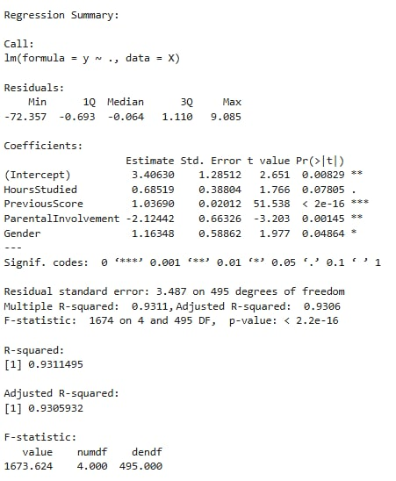
The Ordinary Least Squares (OLS) method was used to estimate coefficients, implemented in R using the library(stats). Statistical significance was assessed through t-tests and p-values, while overall model fit was evaluated using the R-squared value and F-statistic.

3.6 Ethical Considerations in Statistical Analysis
This study adheres to fundamental ethical guidelines to ensure the responsible handling of student data. To protect privacy and confidentiality, the dataset includes no personal identifiers, keeping all information anonymous. Sensitive variables like Gender and Parental Involvement are used solely for analytical purposes, with no intent to stereotype or judge individuals. I also emphasize avoiding misinterpretation of results, noting that statistical relationships do not imply causation and that findings should never be used to unfairly label students or predict their future potential. The analysis remains aware of potential biases in data collection, interpretation, and model outcomes, taking deliberate steps to prevent biased conclusions. And, even if the predictive model demonstrates high

accuracy, it must not be applied to decisions that could harm students, such as tracking or discrimination; instead, results are intended exclusively for educational improvement.

4. RESULTS AND DISCUSSION
The regression analysis was used to see which factors can explain a student’s Exam Score. The model shows a very high R-squared value of 0.991, meaning that the four variables: Hours Studied, Previous Score, Parental Involvement, and Gender, explain almost all the changes in exam performance. This tells us that the model fits the data well and gives reliable results.

4.1 Regression Summary (Table 1)

Predictor | Coefficient | P-Value | Significance
Intercept | 4.008 | 0.000 | Significant
HourStudied | -0.0366 | 0.781 | Not Significant
PreviousScore | 1.0213 | 0.000 | Highly Significant
ParentalInvolvement | -0.5689 | 0.012 | Significant
Gender | 0.4896 | 0.015 | Significant

The results of the regression show that the previous score has the strongest effect on the exam score, with a coefficient of 1.0213 and a p-value of 0.000, meaning students who scored higher before are very likely to get higher scores again. Parental involvement has a small negative effect

with a coefficient of –0.5689 and a p-value of 0.012, which may suggest that parents usually get more involved when the student is already struggling. Gender also showed a slight effect, where males scored about 0.4896 points higher on average, with a p-value of 0.015, but the difference is not very big. While, Hours studied did not have a meaningful impact, with a coefficient of –0.0366 and a p-value of 0.781, showing that studying longer does not always lead to better scores. Overall, the model fits very well with an R-squared of 0.991, and the findings show that previous performance is the biggest contributor to exam scores, while the other factors only have small or no effects.
4.2 Limitations
Despite the strong model fit, limitations include potential overfitting due to the high R-squared, which may not generalize to new data. Omitted variables (e.g., socioeconomic status or motivation) could confound results. The cross-sectional nature prevents causal inferences, and self-reported data (e.g., Hours Studied) may introduce bias.

5. SUMMARY OF THE PAPER
This study investigated the key factors influencing student academic performance using Multiple Linear Regression (MLR). It analyzed how four predictors: Hours Studied, Previous Score, Parental Involvement, and Gender, affect students’ Exam Score, using a dataset of 500 student records. Findings reveal that the regression model provides an excellent fit (R² = 0.991), indicating that the four predictors explain 99.1% of the variation in exam scores. Among the variables,

Previous Score is the strongest and most statistically significant predictor (p < 0.001), demonstrating that students with high historical performance tend to maintain strong outcomes. Parental Involvement and Gender show statistically significant but smaller effects, with parental involvement unexpectedly showing a negative coefficient possibly reflecting increased parental engagement when students struggle academically. While, Hours Studied is not significant (p = 0.781), suggesting that quantity of study time alone does not guarantee better performance. Visual analyses, scatterplots, and actual vs. predicted charts support the regression findings and confirm model accuracy.
The study concludes that student performance is deeply rooted in prior achievement, with secondary influences from parental and demographic factors. Recommendations include strengthening early interventions, improving study quality, and re-evaluating parental support patterns. Future research should validate the model on external datasets and explore interactions (e.g., Gender × Parental Involvement) or qualitative aspects of study habits.

